ASSETS FOR DISPOSAL NOTICE – ONLY UNS-SACCO MEMBERS

United Nations Staff SACCO Uganda is registered under the Uganda laws governing SACCOs and started serving the UN Employees of Uganda in November 2009 to address the challenges faced by the UN Staff in accessing affordable and manageable credit facilities.

United Nations Staff SACCO invites bids from interested bidders to purchase these items.

- The above mentioned office equipment and furniture shall be sold on ‘’as is, where is’’ basis and UNS-SACCO will have no further liability after sale. No guaranty or warranty given.
- Interested bidders will inspect the asset at SACCO offices located at PLOT 89, AGA HOUSE MAWANDA ROAD from 22nd October 2018 between 08:30am and 04:00pm.
- The deadline for bid submission shall be on 02nd November 2018.
- The detailed bid document is available at no fee.
- The highest bidder takes the provided item and payment must be done within 5 working days.
- Successful bidders will deposit directly to the UNS-SACCO bank account and bring within 5 working days the bank slip receipt attesting proof of the payment. Otherwise the second highest bidder will be invited to pay for the items.
- UNS-SACCO reserves the right not to award any item should the best winning price not reach its expectations.

DOMESTIC BIDDING FORM – ONLY UNS-SACCO MEMBERS.
Description of items ………………………………………………………………..
Item Reference ……………………………………………………………………..
Buyers Full Name ………………………………………………………………….
Postal Address ……………………………………………………………………..
Mobile Phone Number ……………………………………………………………
Bid Amount (UG Shillings) ………………………………………………………..
Signature …………………………………………………………………………..
Date ……………………………………………………………………………......

Note
- Use a separate form for each lot you bid for.
- All fields are mandatory. You will be disqualified from the process if any field is not filled.
- Bidders are requested to carefully read and adhere to all conditions in the advert.

ITEMS FOR DISPOSAL AT UNS-SACCO UGANDA LTD

Disposal Ref No. | OFFICE EQUIPMENTS
UNS-SACCO/16/075 | Money Counting Machine | Re-advertised
UNS-SACCO/12/046 | HP Laser Jet Printer | Re-advertised
UNS-SACCO/12/038 | Generator

Disposal Ref No. | FURNITURE & FITTING
UNS-SACCO/12/08 | High Back Fabrics Chair | Re-advertised
UNS-SACCO/12/021 | High Back Fabrics Chair | Re-advertised
UNS-SACCO/15/063 | Executive Fabrics Chair | Re-advertised
UNS-SACCO/14/062 | High Back Swivel Chair | Re-advertised

High Back Fabrics Chair

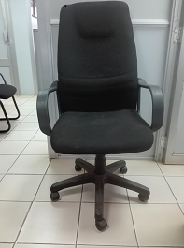

Executive Fabrics Chair

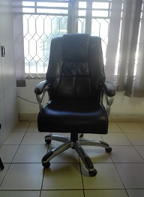

High Back Swivel Chair

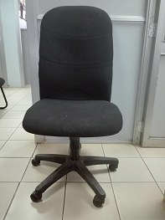

Money Counting Machine

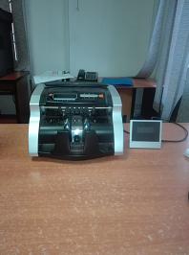

HP Laser Jet Printer

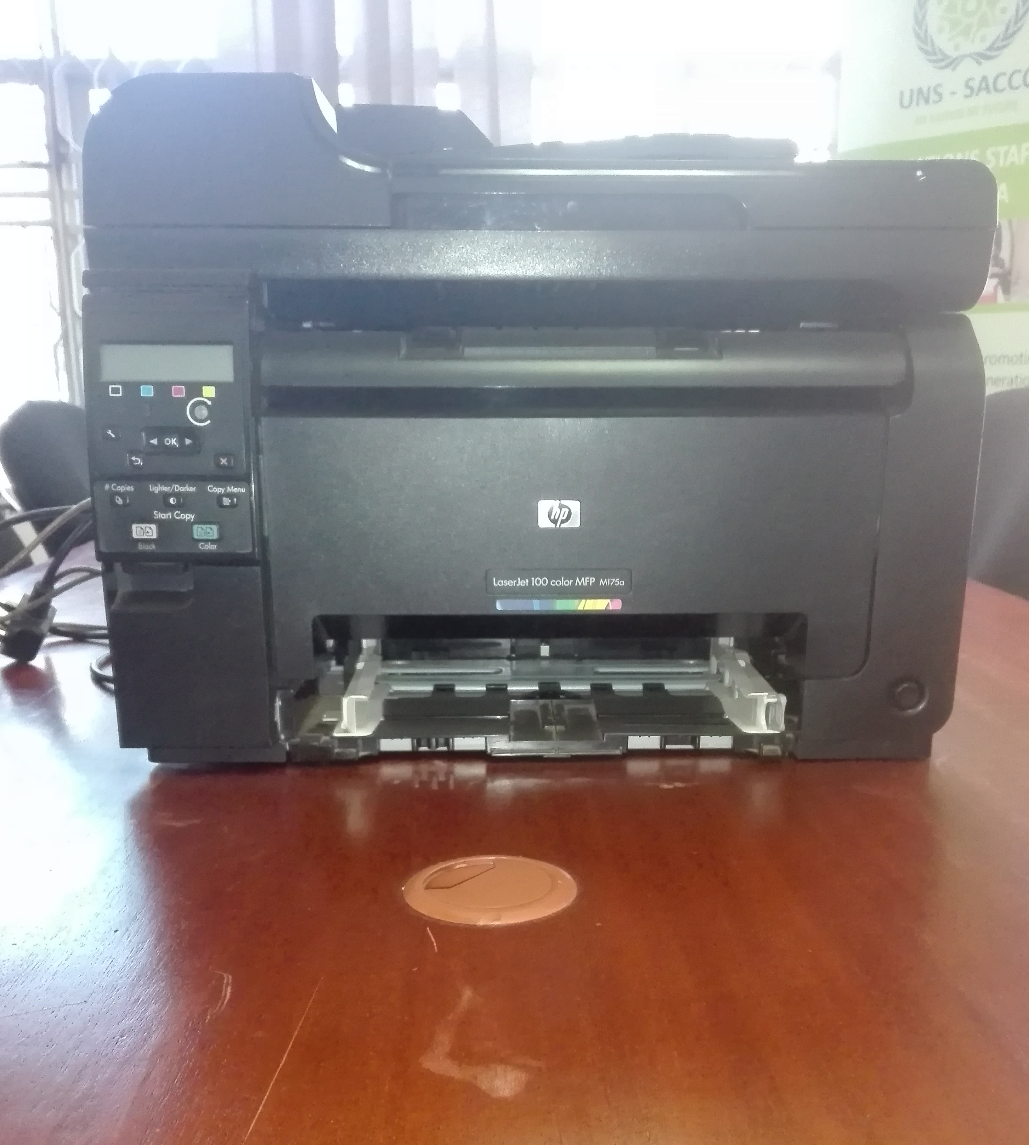

Generator



